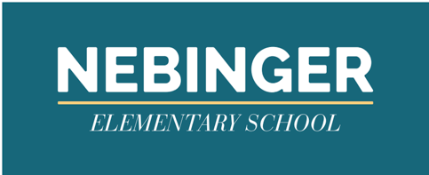
May 24, 2021

Dear Nebinger Parent/Guardian,
We consider the health and safety of our students and staff to be of extreme importance and are working closely with the Philadelphia Department of Public Health (PDPH) to help mitigate the spread of COVID-19. This letter is to inform you that today, May 24, 2021, we were informed that a student or staff member at Nebinger Elementary tested positive for COVID-19.
The staff member or student was last in your building or office on May 21, 2021.
In accordance with Health Insurance Portability and Accountability Act (HIPPA), the Family Education Rights and Privacy Act (FERPA) and other state privacy laws, we cannot share any additional information about the person. However, please know that the individual is self -isolating and will not return until all CDC guidelines are met.

IF your child is identified as someone who may have been in close contact (defined as being within six feet of the person for more than 15 minutes within a 24-hour period with this person, you will be contacted by PDPH and/or Student Health Services with important information concerning the need for your child to quarantine and participate in virtual learning for 10 days. If your child develops symptoms of COVID-19 at any point during quarantine, self-isolation should begin and testing should be performed.

As an extra precaution, we encourage you to monitor your child closely for the common symptoms associated with COVID-19 listed in the chart below.

Symptoms of a COVID-like Illness
If you have at least ONE of these symptoms:  - cough  - shortness of breath  - new loss of sense of smell  - new loss of sense of taste | OR | If you have at least TWO of these symptoms:  - fever of 100.4 F or greater  - chills  - muscle pain  - headache  - sore throat

If your child experiences any symptoms in the left box or two or more symptoms in the right box, you should be tested for COVID-19. To find a testing site near you, please visit www.phila.gov/covid-testing-sites. Should you have questions or immediate concerns, please call the Philadelphia Health Department’s COVID-19 Hotline at 215-685-5488.

As a reminder, all hard touch surfaces in our school are cleaned a minimum of every four hours, and extra cleaning and disinfecting is done in any area that the person who tested positive may have come in contact with.
Thank you, take care and stay safe.

Sincerely,
NSL

