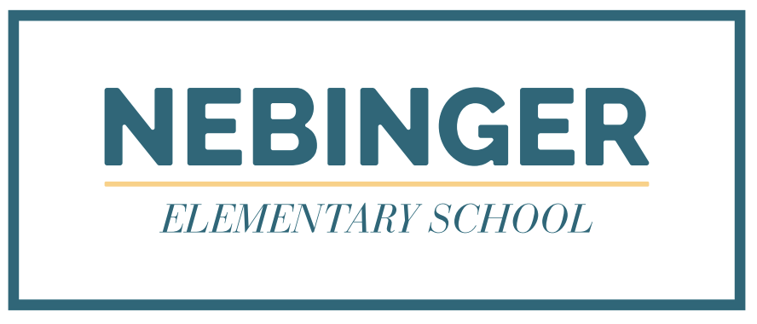

Dear Parents/Guardians,

The School District of Philadelphia will begin slowly and safely phasing in groups of students to a mix of in-person and digital learning (hybrid learning). PreK-2 students whose families selected hybrid learning during the initial selection process in the fall will phase in first, beginning on Monday, February 22nd if they still choose to do so. Otherwise, they can remain 100% digital. PreK-2 families who chose to remain in the 100% digital learning during the selection process in the fall must remain digital at this time but will have the chance to opt in at a later date as long as we can safely phase in more students.
Students opting into hybrid learning will be assigned a schedule where they would attend school in person two days per week, either on A Days (Monday & Tuesday) or B Days (Thursday & Friday). On the remaining three days each week, they will engage in digital learning remotely as they have done since the beginning of the school year.
To prepare for a safe transition, PreK-2 teachers will need additional time during the work day from February 8-19. They will use this time to prepare their classrooms and engage in health and safety training and instructional professional development.

Here’s what that means for our students and families:
- PreKindergarten school schedules will be adjusted as follows:

Monday, February 8 | Asynchronous (self-paced and independent) learning only. No synchronous (live instruction) learning will take place.
Tuesday - Thursday, February 9 - 11th and Tuesday - Thursday, February 16-18 | Synchronous (live) instruction will resume. However, you may notice an increase in the amount of asynchronous learning time so that teachers can be available for professional development and additional classroom setup. Your child’s Pre-K teacher will communicate these changes to you.
Starting February 22 | Regular daily schedule resumes with one important change: weekly half-days will now occur on Wednesdays instead of Fridays for the remainder of the school year.

- Kindergarten-Grade 2 school schedules will be adjusted as follows:

Monday, February 8 | Asynchronous (self-paced and independent) learning only. No synchronous (live instruction) learning will take place.
Tuesday - Thursday, February 9 - 11th and Tuesday - Thursday, February 16-18 | Synchronous (live) instruction will resume. However, you may notice an increase in the amount of asynchronous learning time so that teachers can be available for professional development and additional classroom setup. We will communicate these changes to you.
Starting February 22 | Regular daily schedule resumes. with one important change: weekly half-days will now occur on Wednesdays instead of Fridays for the remainder of the school year.

As a reminder, students who are not fully immunized will not be admitted to in-person instruction and must remain remote until fully immunized. Please contact your school’s nurse with immunization questions or your child’s teacher with scheduling questions. Thank you for your flexibility and patience as we prepare for this important transition to support the varied learning needs of our students.

Natalie St. Louis-Catin
Principal
Nebinger Elementary

